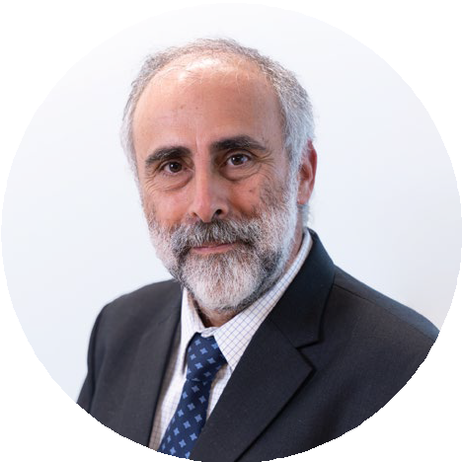

**Pedro Verdelho**

President of the Board

ERSE - Energy Services Regulatory Authority

# Professional Experience:

* President of the Board at ERSE (since November 2021)
* Member of the Board of Directors at ERSE (2019 – 2021)
* Chair of the Electricity Working Group at ARIAE – Ibero-American Association of Energy Regulators (since May 2025)
* Chair of the Gas Working Group at ARIAE - Ibero-American Association of Energy Regulators (2022-2025)
* Vice-President of CEER - Council of European Energy Regulators (since March 2021)
* Head of Pricing and Tariﬀs Division at ERSE (1999-2019)
* Chair of the Gas Working Group at CEER and ACER - Agency for the Cooperation of Energy Regulators (since March 2019)
* Chair of the Renewables Working Group at MEDREG - Mediterranean Energy Regulators (since November 2018)
* Chair of the Gas Working Group at MEDREG - Mediterranean Energy Regulators (2014-2018)
* Researcher at the Centre for Innovation in Electrical Engineering and Energy at the Instituto Superior Técnico of the Universidade Técnica de Lisboa (2007-2013) and at the Centre for Automation in the same Institute (1985-2007)
* Assistant Professor at the Instituto Superior Técnico of the Universidade Técnica de Lisboa (1995-1999)

# Education:

* Ph.D., Master’s and Undergraduate degrees in Electrical and Computer Engineering at the Instituto Superior Técnico of the Universidade Técnica de Lisboa (1995, 1990 and 1987, respectively)